Installing and testing Apollo

# Install R

1. Go to <https://cran.r-project.org/> and follow the instructions to download R for your operating system. **Please note you require at least version R4.0 in order to run Apollo.**

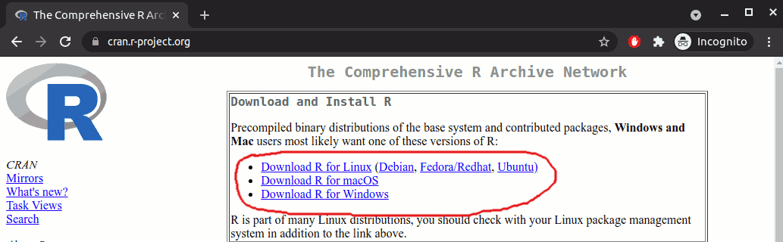

For example, for windows, download the base R:

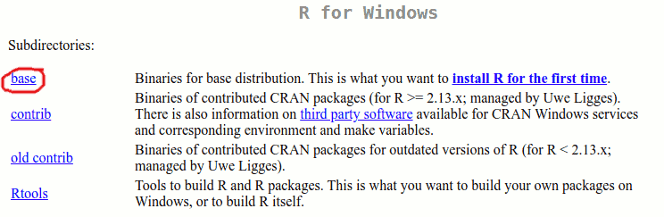

1. After downloading the appropriate file, double click on it and install it following the instructions that will show up on your screen.
2. Depending on your operating system, applications need to be digitally signed. You may therefore need to unblock the setup files of both R before being able to install it.

# Install RStudio

1. Go to <https://www.rstudio.com/> and click on “Download”:



1. Scroll down and select the “Free version” for downloading

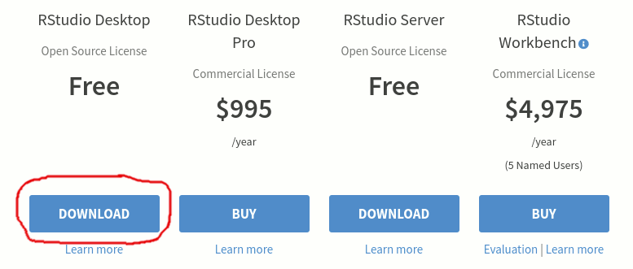

1. Scroll down and download the installer for your operating system:

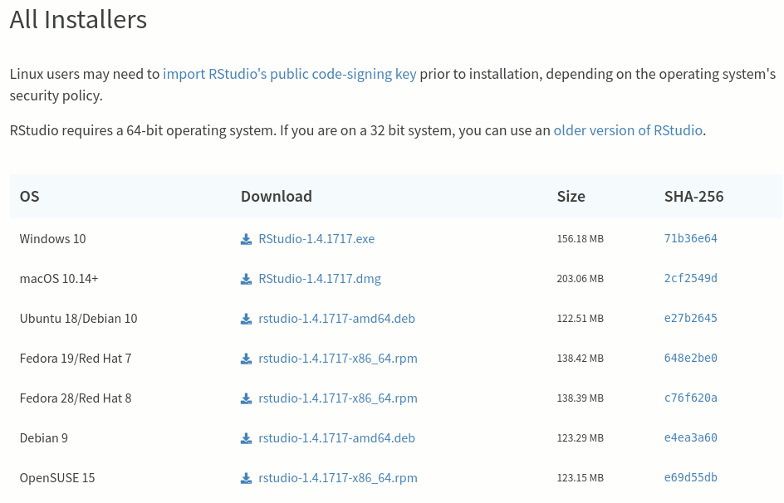

1. After downloading the appropriate file, double click on it and install it following the instructions that will show up on your screen.
2. Depending on your operating system, applications need to be digitally signed. You may therefore need to unblock the setup files of both RStudio before being able to install it.

# Install apollo in RStudio

1. Open *RStudio*
2. In the console, type  
   install.packages("apollo")  
   Press the *enter* key, and wait for installation to complete.  
   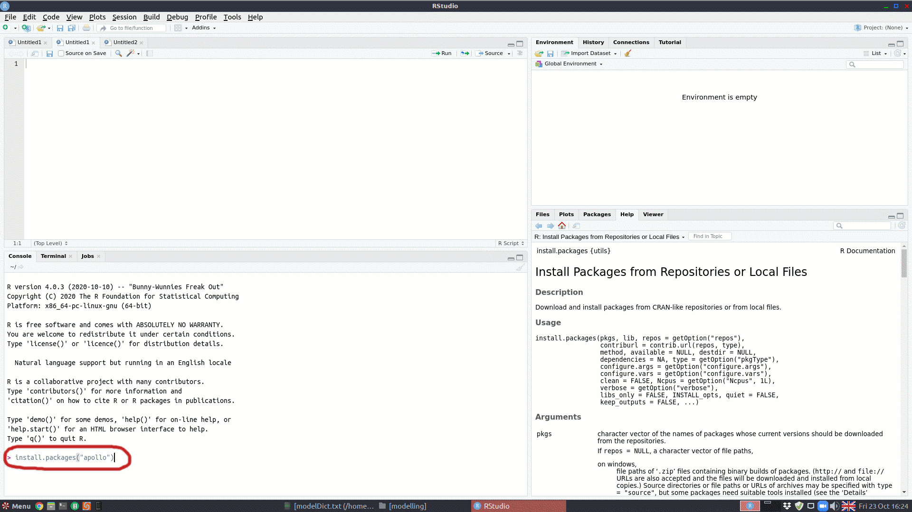
3. If everything went well, you should see that at least apollo version 0.3.1 is installed (look at the packages section, which will be in your lower right or lower left panel depending on your configuration).

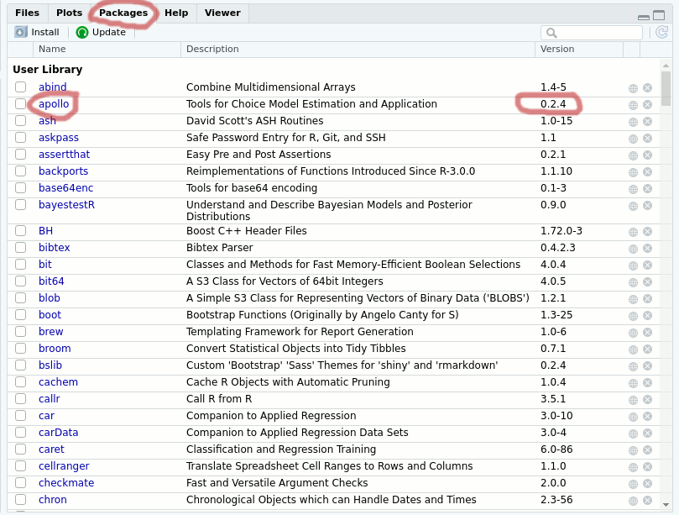

# Run example

1. Download the example file from the following link:  
   <https://www.dropbox.com/s/x7rqwz8bai8n5g4/MMNL.r?dl=1>
2. Open the downloaded file in Rstudio (you can double click on the MMNL.r file).
3. Then select all text in the script tab, and press *Run*.  
   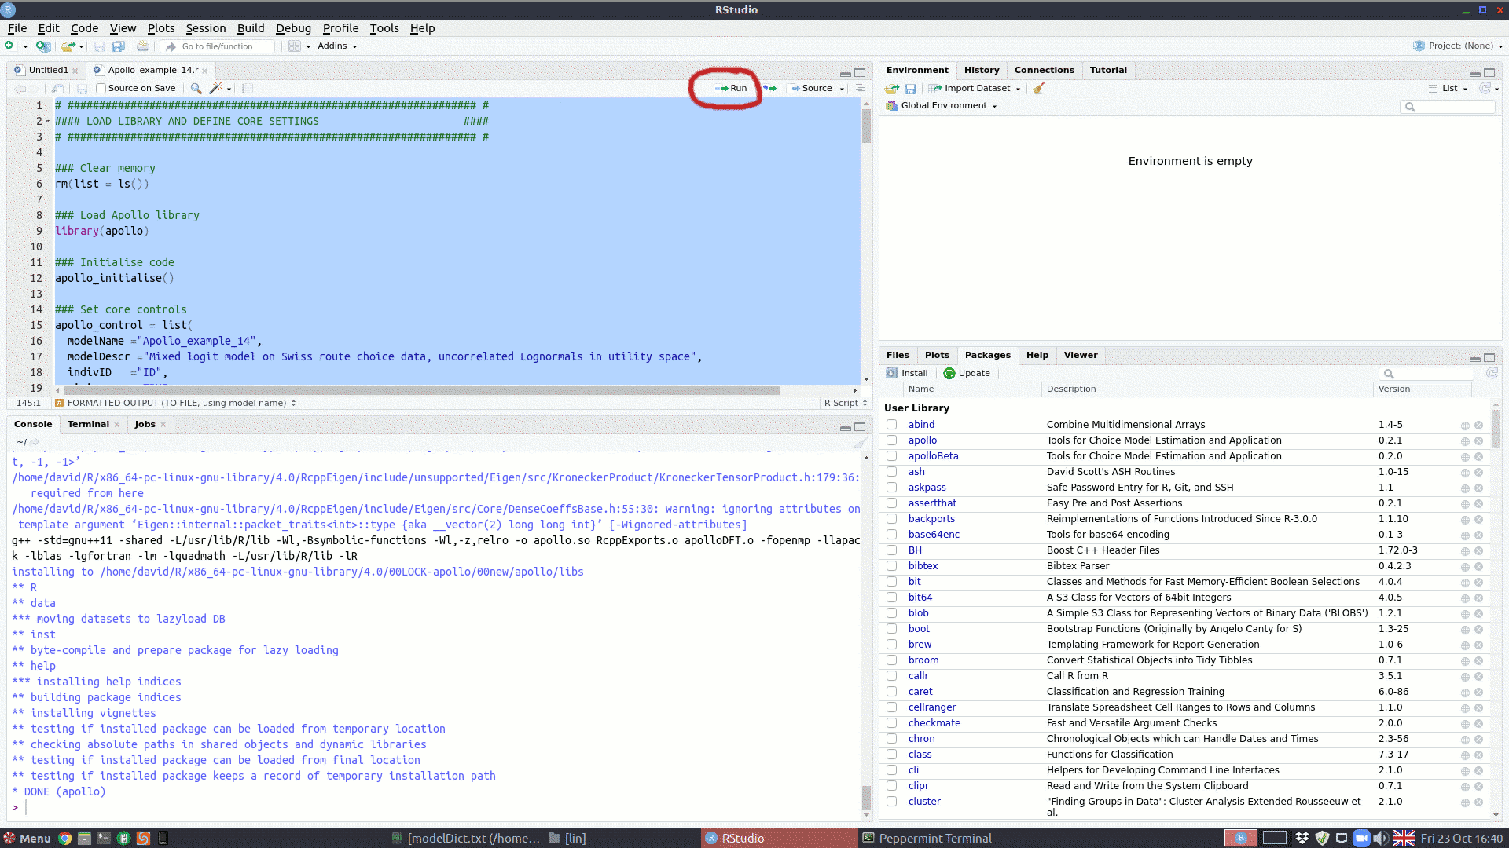
4. After the estimation finishes, a report should be printed to the Console.  
   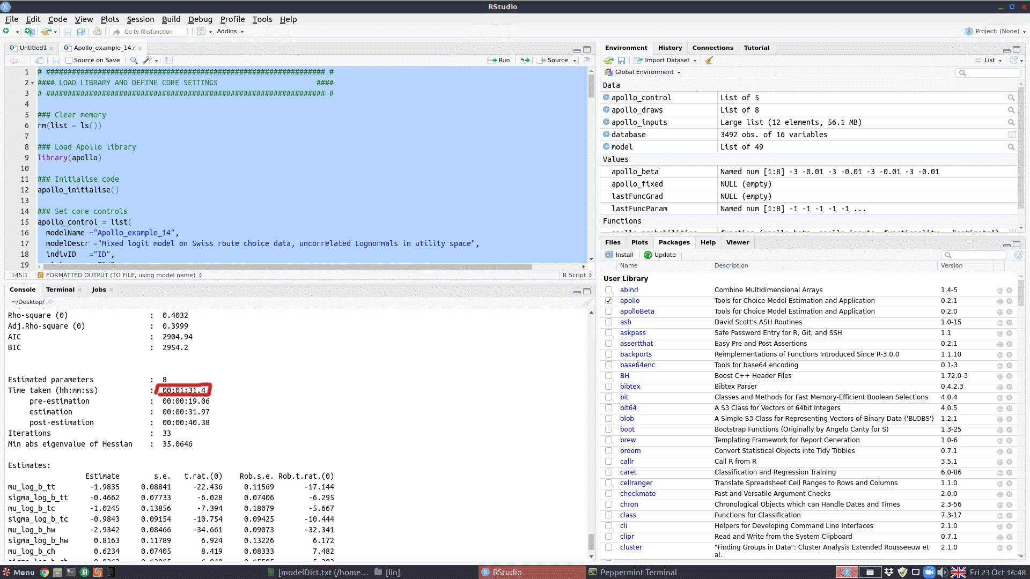
5. If the model estimated correctly (i.e., it did not generate any errors), then everything is working as it should. The run time should not be substantially higher than in the above output.